

**Cloud Deployment Models**

**Name:** Pratham Kandari

**Sap Id:** 500097663

**Batch:** 7

**LAB- 5**

**Deploy a VM from an image Snapshot**

Step 1) Go to your Instance, On the right side you will see, create snapshot option, click on that.

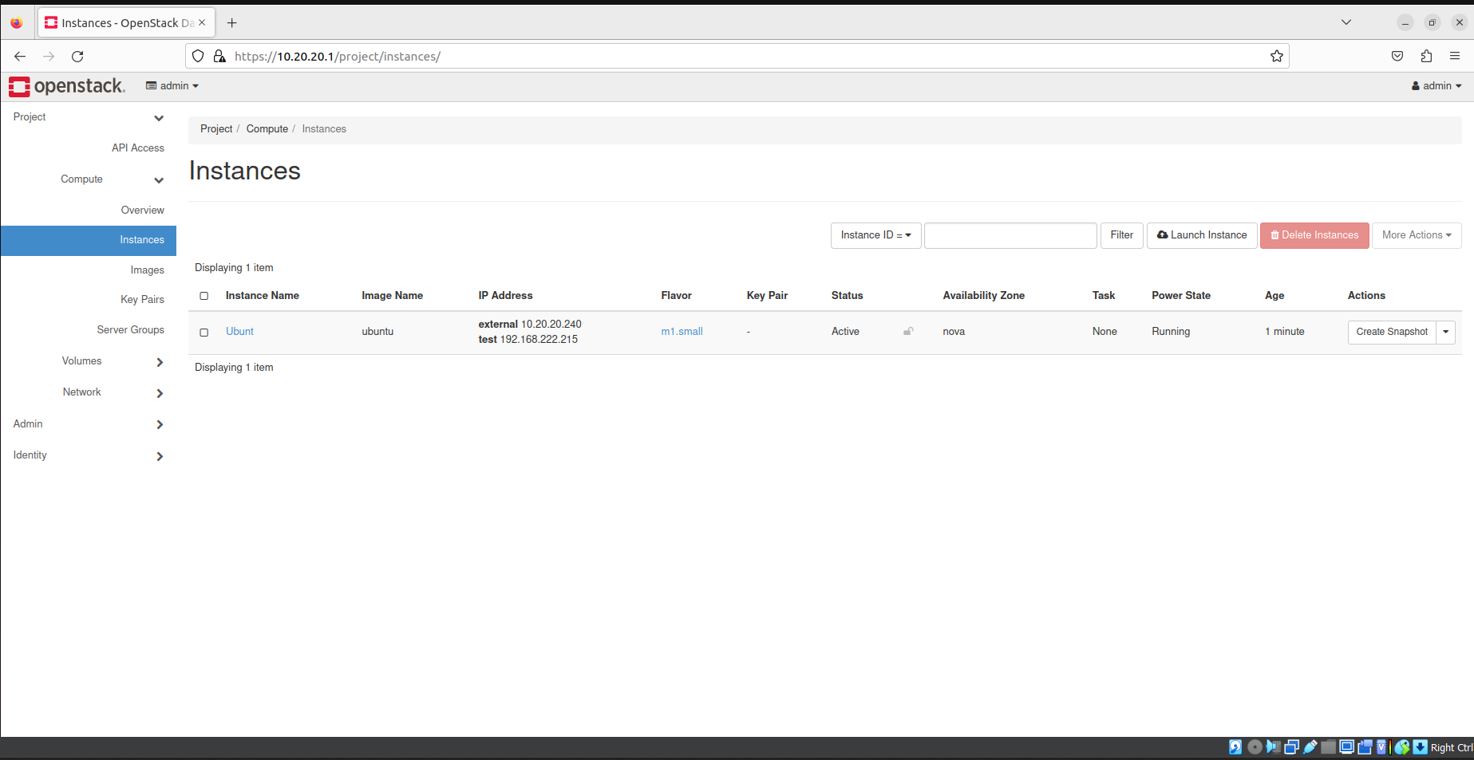

Step 2) Give it a name.

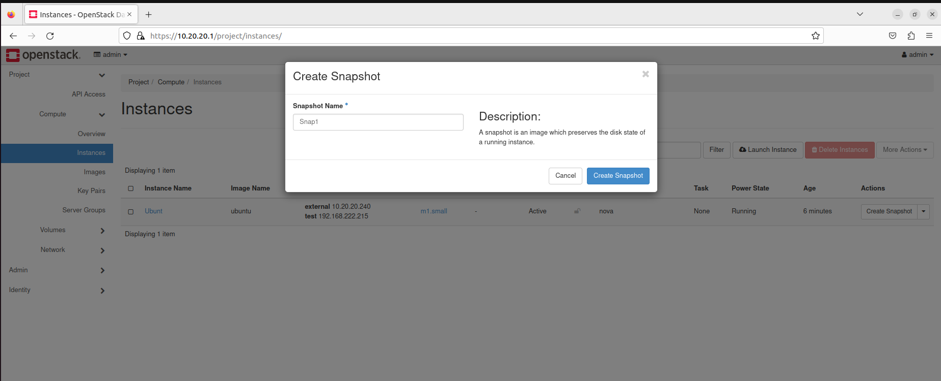

Step 3) Your snapshot will be created under Images.

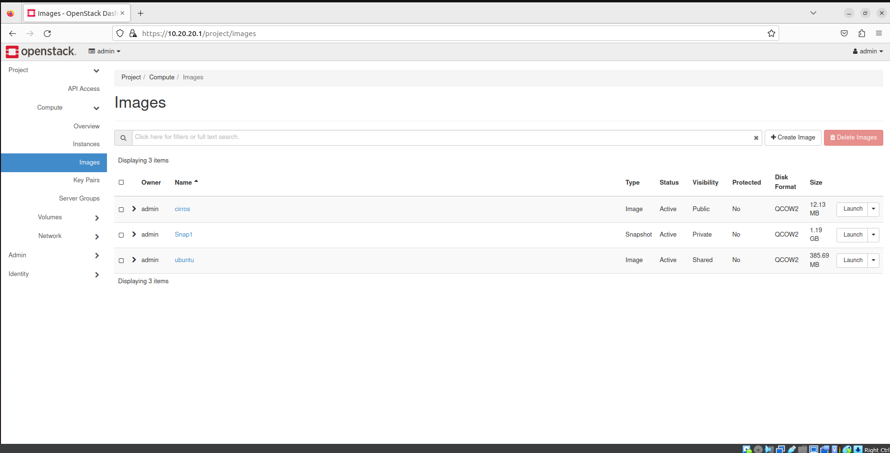

Step 4) Click on Launch Instance, give it a name.

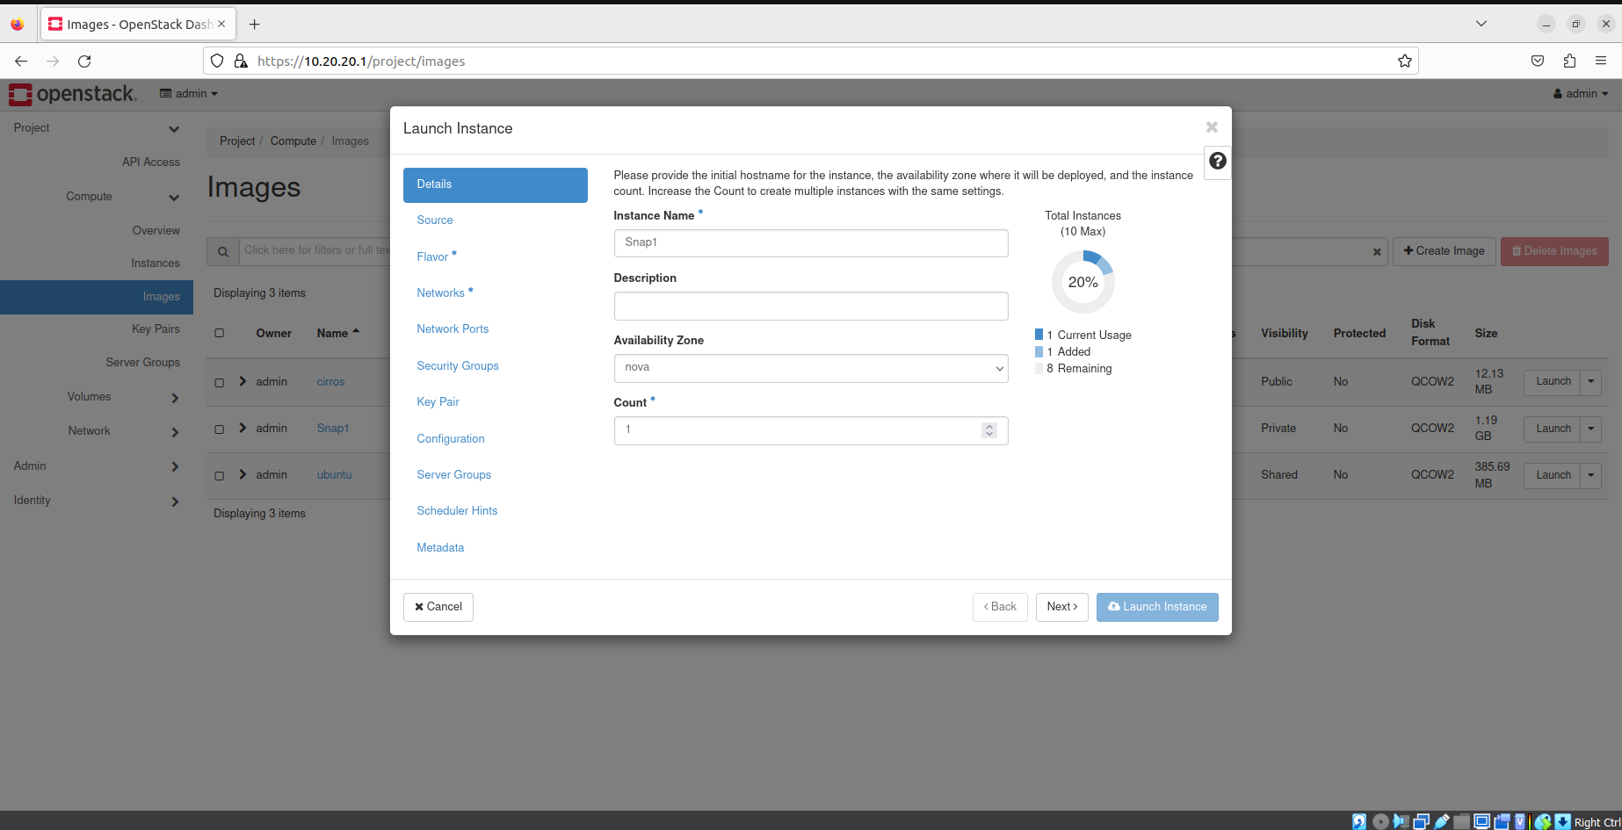

Step 5) Select Boot source as Snapshot.

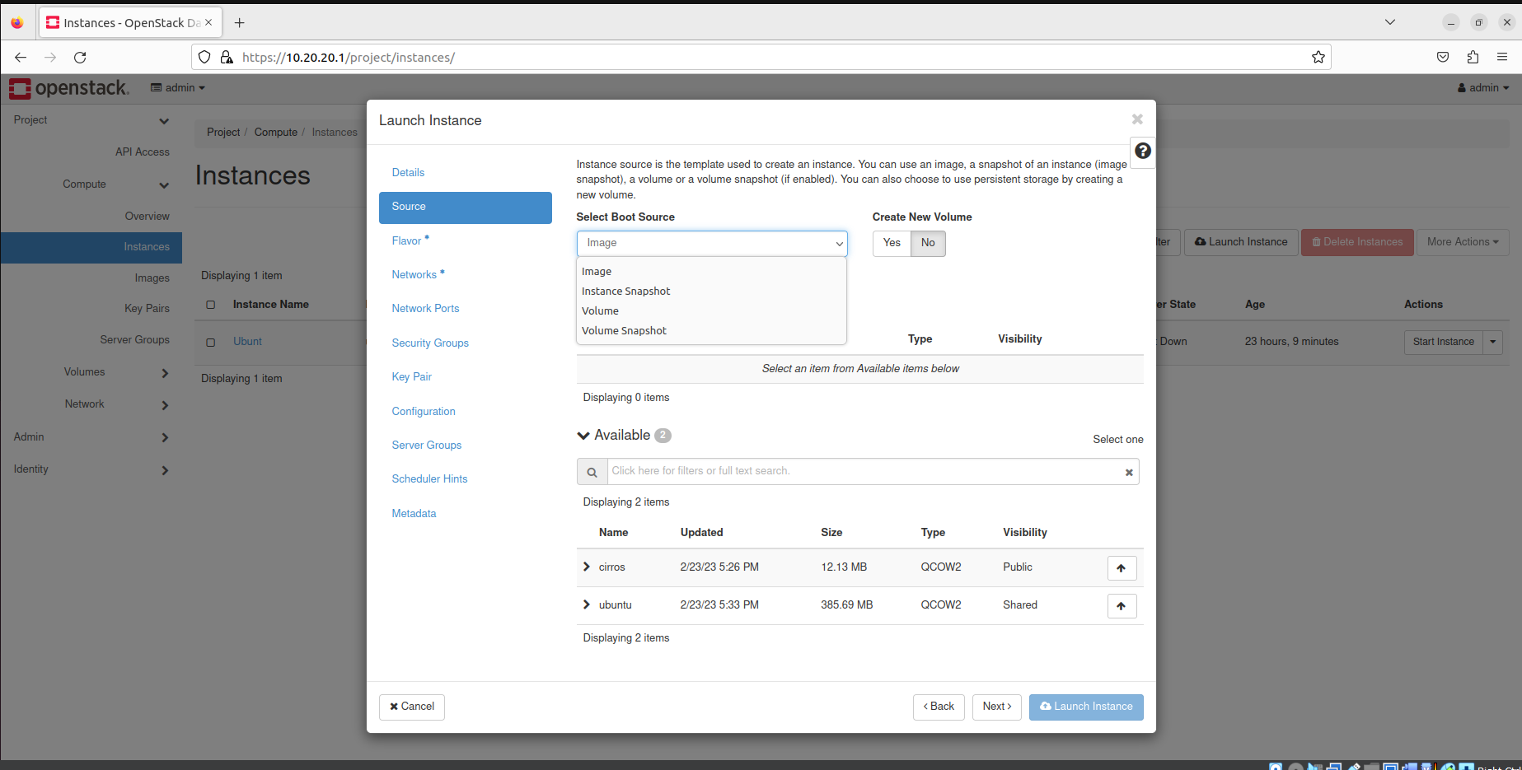

Step 6) And select you snapshot.

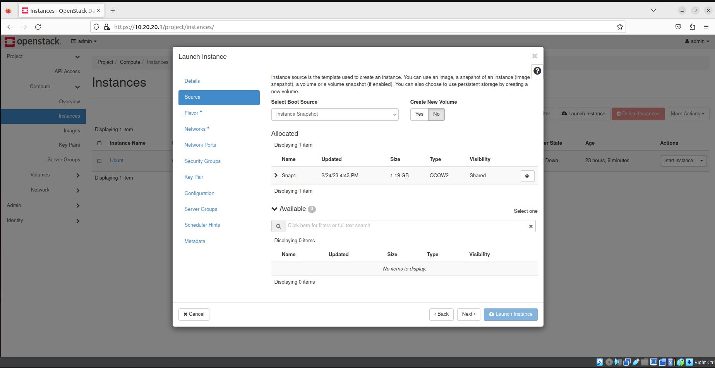

Step 7) Select appropriate configuration.

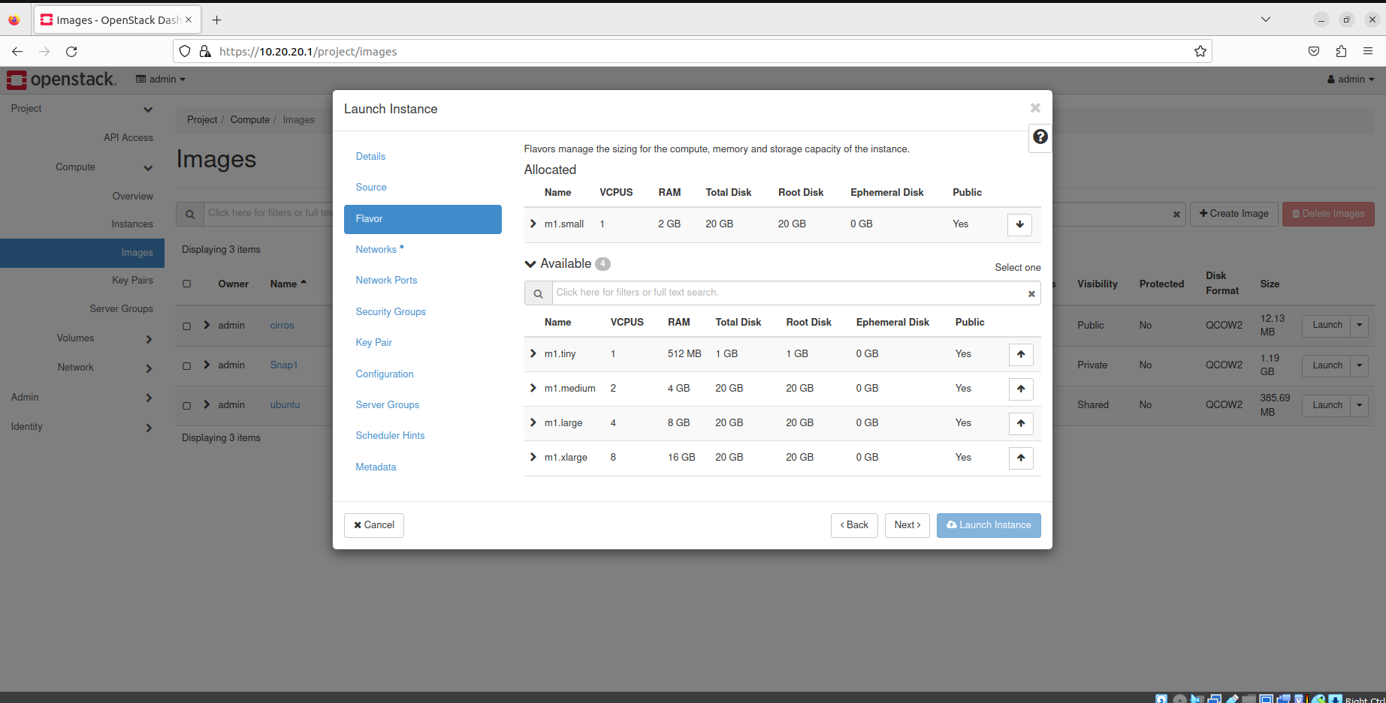

Step 8) Select both networks.

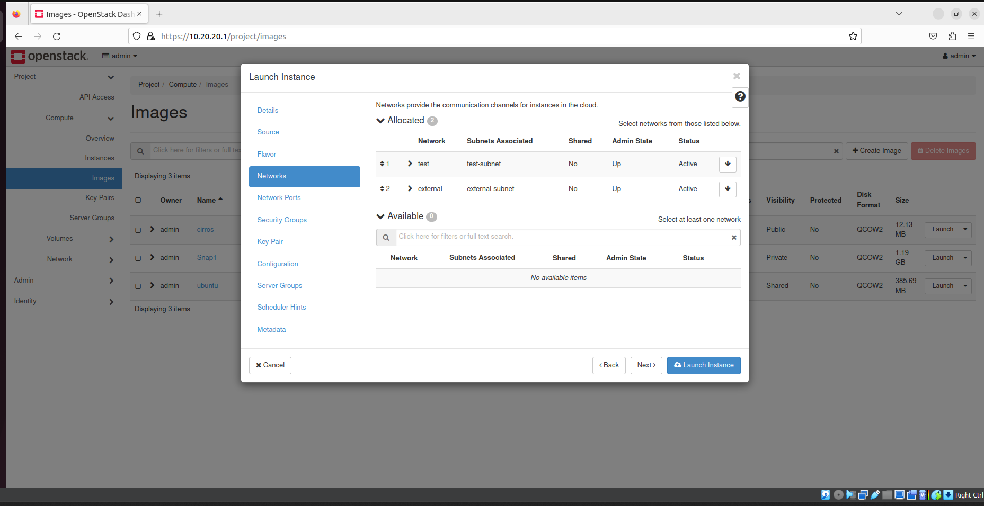

Step 9) Select key pair if you want and launch it.

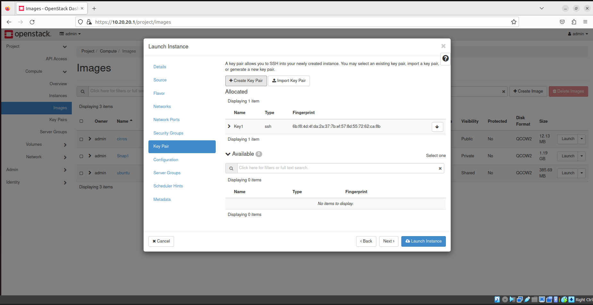

Step 10) Click on the instance.

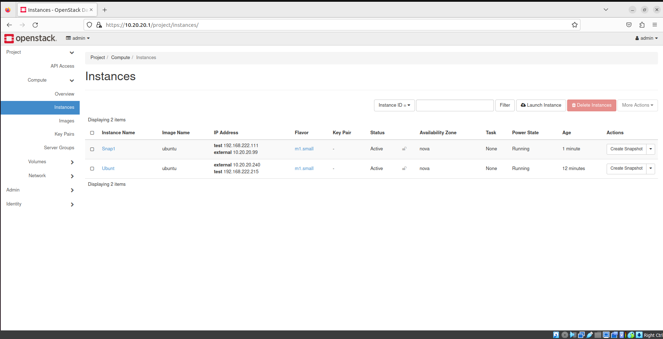

Step 11) Go to console and open console.

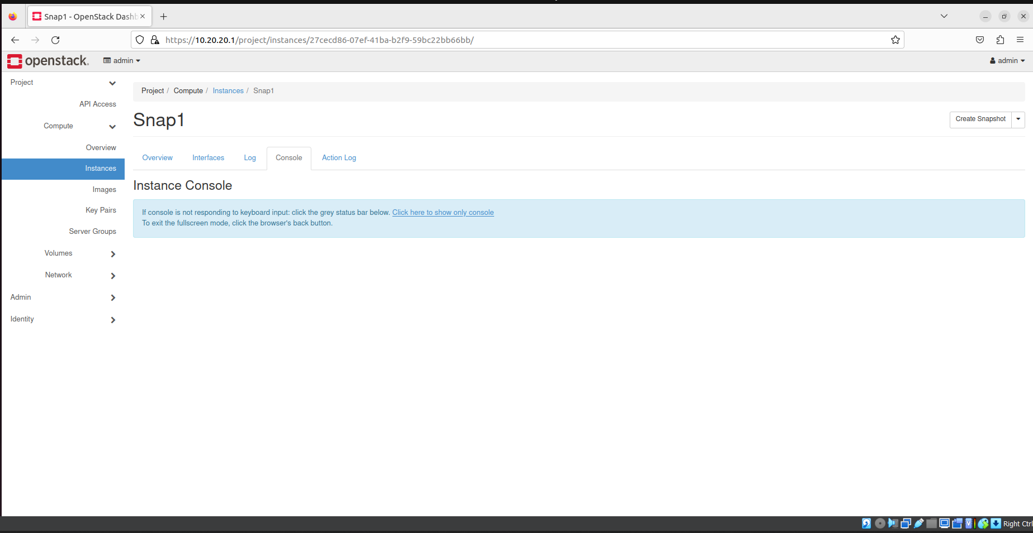

Step 12) And your console will Open.

